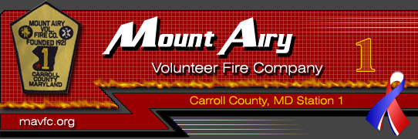
Join the
Mount Airy Vol. Fire Co. Juniors Program

The Mount Airy Volunteer Fire Company’s Juniors Program
is open to young people ages 12 to 15 who wish to learn
about firefighting and emergency medical services

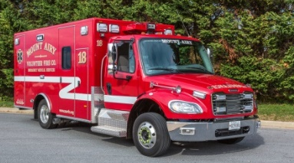
As a Member of the MAVFC Juniors:
- Earn community service hours
- Learn skills in leadership, teamwork, and being a first responder
- Participate in training, work details and company meetings
- Patricipate in fund raising activities (e.g. breakfasts and annual carnival)

Meetings are held the second Monday of the month at the fire station, typically followed by a training such as:
- Radio Operations - Fire Figher Tools and Equipment
- Hazardous Material Awareness - Personal Protective Equipment
- Firefighting and Rescue Overview - Self-Contained Breathing Apparatus (SCBA)
- Familiarization with Fire Apparatus - Ropes, knots, basic repelling
- Portable Fire Extinguisher Use - Search & Rescue
- Fire Hose, Nozzles, Streams - Vehicle Rescue & Extrication
- Emergency Medical Basic Skills - Vital signs, bleeding control, splinting, c-spine immobilization
- Cardiopulmonary Resuscitation (CPR)

Junior Members will be allolwed to participate in special events, such as the annual Mount Airy Fire Company’s Carnival and Carroll County Volunteer Emergency Services Association (CCVESA) Junior Firefighters Day at the Carroll County Training Center in Westminster. This CCVESA annual event includes participation of Junior Firefighters from all fourteen Carroll County fire companies where they come together for a day of training, comraderie, and competitions.

JOIN US!
For more information please call (301) 523-4992
or send an e-mail to juniors@mavfc.org

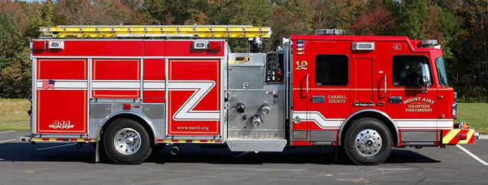
On the Web:
http://www.mavfc.org/content/juniors/

